# Project title

Soccer

**Name of the project**

Soccer Game Management System

**Team members**

Huzefa Sadikot

Atreya Raorane

**Project Scope and Planning**

As the name suggests the main purpose of the database is to keep record of all events, games, player Profile, country leagues, private games. We are planning to make a working database which can store data related to games, and player which are related to each other. We want to make a system which can make viewing and storing all data related to this sport easy and fast. We want a system which is reliable and consistent. Each table has a unique significance to it with minimal redundant data.

The main purpose to make this project is to bring all the data from different database under one system. Currently there are different databases for player Profile, Games, Different Leagues, World cups etc. We intend to calculate different score boards, number of matches played by players, number of goals made by players depending upon this query can be fired to find a combined data and a customized view according to user’s needs as calculated fields. Also, this can be customized to view the statistics for favorite players.

**How will scouts use this database:**

When scouts need young players for their team, they need player data to see many factors before picking them up for a particular role.

Here the schema is dbo and the table names used are displayed below:

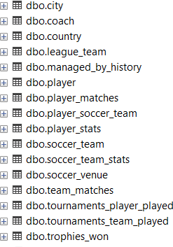

**Logical Data Model**

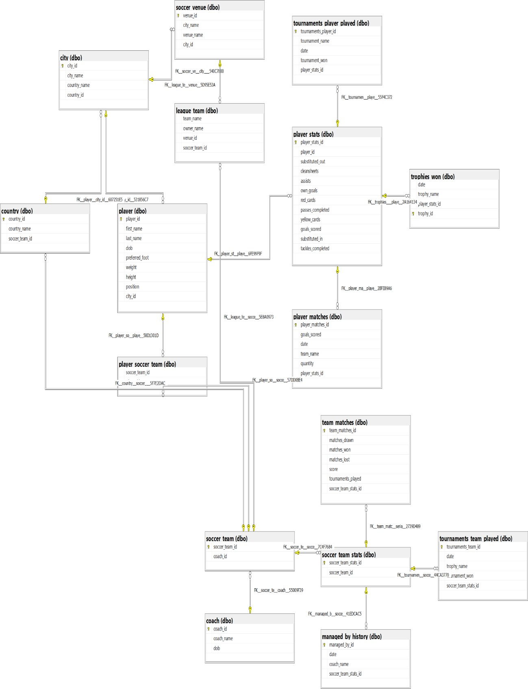

**Create Database and load Data**

**Database we created is in 2NF**

To create the database the following command is used;

**CREATE DATABASE soccer;**

To load data in the database insert query is used: -

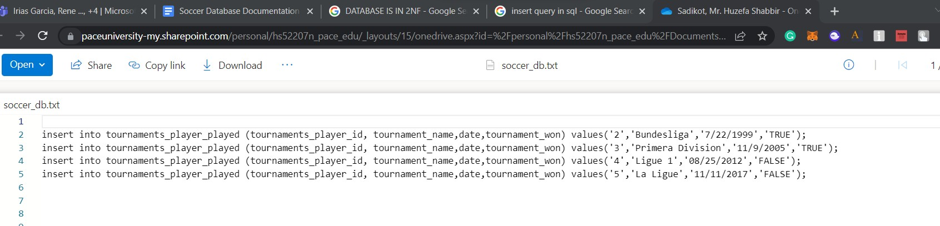

A view can be created for the user to see precise data referring to a specific topic

We have created 3 views

1. Top_Player_Statistics
2. Player_unavailibility_view
3. Young_Player_Statistics Let us see how to create one view

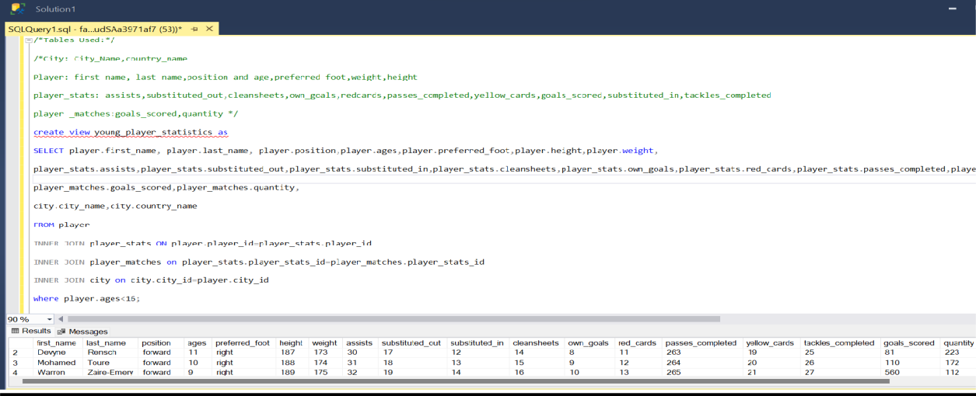

## Report and Visualization

Create, Insert, and view are the query that we have used for the soccer database

**Create query**

While creating the database for soccer we mainly focused on the primary key, the foreign key of the table created, and the datatypes of the column.

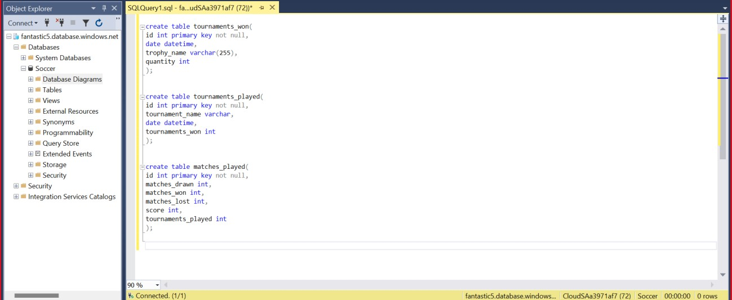

Also, we have used the following queries:

1. **Update Query:** UPDATE table_name SET column1 = value1, column2 = value2, WHERE condition;
2. **Alter Query**: ALTER TABLE table_name ADD column_name datatype;

## Conclusion & Lessons learned

Around 5 data sets are added to each table and more data can be added to the database as per the user's requirements. This database can be implemented in docker, but it requires WSL (Windows Subsystem for Linux) and docker desktop to run, which makes its usage heavy.

AWS can be used instead but it can be expensive if there's a budget limit for the user. Hence, we used azure as it comes with some credits which are free for college students, also it works well with the Microsoft environment security is good and setup steps are easy as most of the parts are pre-installed or easily available. We have designed the database in which the tables are in second normal form(2NF).

## Further scope

We can increase normalization further (as we have used 2NF). Apart from this, we can use indexing to increase query performance. Apart from this Data Defragmentation can be used to improve database performance.

Also, CPU speeds and memory can be increased or decreased, depending on the customization made on the virtual machine depending upon the clients/user's budget.

**References**

* Fundamentals of Database Systems, 7/e Elmasri, Navathe, 2017, Pearson, ISBN-10:1292097612 and ISBN-13: 9781292097619.
* <https://www.w3schools.com/sql/>